IT6037 Project Planning Document
Team Name
Nepali Tech

Team Members
Student | Student Name | Student ID
Student 1 | Aashish Sagar Basyal | 20240483
Student 2 | Emon Aryal | 20240153
Student 3 | Sabin Pandey | 20240184
Student 4 | Udit Neupane | 20241049
Student 5 | Keyur Bhaveshbhai Patel | 20231990

1. Introduction 3
2. Project Objective 4
3. Development Methodology 5
4. Collaboration Tools 5
5. Project Scope 8
6. Requirements Analysis 8
7. Iteration Planning 9
Stage 1 10
Stage 2 10
Stage 3. 11
Stage 4 11
Stage 5 12
8. Task Allocation 12
9. Current Progress 13
10. Risk Management 14
11. Kanban Board 15
12. Client Feedback 19
13. Conclusion 21

1. Introduction
This planning document has been created for the IT6037 Project assessment and will be used as a detailed plan for the group project. This document describes the overall development strategy, project schedule, task allocation, collaboration processes and project risk management processes that the team will implement throughout the Software Development Life Cycle (SDLC). The main objectives of this project are to analyze, design, develop and test a web application which uses the database to manage digital learning materials for school students. The suggested system has been designed to offer a platform that will enable students, tutors, and administrators to store, manage, and retrieve educational content efficiently. The educational resources will be placed on the database in three major subject areas: • Art • Mathematics • Technology For each of the subjects there will be several articles on important concepts, events, biographies of key people and important objects. The application should have different user roles and offer varying levels of privileges for each of them. This planning document is a critical element in making sure all team members understand the project needs, project goals, project deliverables, project deadlines and project responsibilities. A structured approach will help the team manage project risks, enhance communication and ensure the assessment is completed. The team will adopt the principles of the Agile method of development, breaking the project into small steps. This enables flexibility, continual progress monitoring and frequent project outcomes review throughout the project life.
2. Project Objective
This project aims to develop a user-friendly, efficient, and secure database application that will enable the efficient management of educational resources. The information should be stored, retrieved and organized in a structured and organized manner within the system. The final solution should consist of one page web application that is linked to a functional database. The project seeks to accomplish the following goals: Identify and create an efficient database design for storing educational content. Use secure user authentication and role-based access control
• Design an interactive and easy-to-use website Allow fast retrieval and navigation of articles
• Support CRUD operations based on user permissions Conduct tests for system reliability and performance.
The system should satisfy the needs of three primary user groups:
Students
Students should be able to browse articles by category and search for articles using keywords in the article title.
Tutors
Tutors should be able to add new articles and modify existing articles within the database.
Administrators
Administrators should have full control over the system, including the ability to add, modify, and remove articles.
The successful completion of this project will demonstrate the team’s ability to apply software development principles, database management techniques, user experience design, and collaborative development practices.

3. Development Methodology
The main framework the team intends to use to develop this system is Agile development, that being our chosen development model. An Agile development methodology is an iterative model that the teams use for producing software. It’s characterized by the collaboration of team members, adaptability to the circumstances during development, flexibility in its development process, as well as continuous improvement over the course of time.
The Agile development model works for this particular project due to a couple of interdependent factors as: the stages in which this project would be worked upon, requirement analysis, planning, design database schema, development, querying, build the website and development the website, then deployment, and then testing.
Using smaller increments allows team members to check for potential changes in their progression during the development of the project and accordingly make adjustments to suit their work flow. As this project will contain a multitude of development stages, a number of stages would include tasks, to be undertaken and at the completion of each phase, a meeting to check the status will occur so that the development of the product would occur. Some of the best benefits that come about by using Agile method: The team has increased the rate of communication between the developers Enhanced management and tracking tasks Problems and blockers will be solved a lot earlier Adaptable when change needs to be made Team improvement throughout its cycle Daily meetings, challenges discussions, task assignments would take place between the members of the team to ensure every member of the team stays on top of their tasks in hand, as well as ensuring everyone has clear objectives. They will also make use of a number of online and collaboration based systems such as: Trello, GitHub, a communication tool etc, to allow the team to make use of agile on a technical level.
These tools will permit to facilitate versions control, as well as allowing the team to task manage, communication, and make documentation all more available.
The team wishes to facilitate all movement of their development and also to make the team more cohesive, in order to ensure that they fulfill their project before the deadline that has been issued by this institution.
4. Collaboration Tools
To complete this project effectively, it is crucial that collaboration be effective. The project requires several members to work on various tasks at the same time, so the team has adopted suitable collaboration tools to better communicate, coordinate tasks, document and control the version.
The selected collaboration tools are listed below:
Purpose | Tool
Communication | Teams
Documentation | Google Docs / Microsoft Word
Version Control | GitHub
Task Planning | Trello
Communication Tools
Effective communication is crucial in keeping everyone on the team informed and on track with the project's objectives. Discord and Messenger are used by the team to communicate instantaneously, to hold fast discussions, to update progress and to solve problems.
These tools enable team members to:
• Share updates quickly
• Ask technical questions
• Resolve issues efficiently
• Coordinate meetings Frequent communication minimizes miscommunication and helps teams work together more smoothly.
Documentation Tools
Project documents including planning documents, system design documents, testing reports and reflective journals are prepared and managed using Google Docs and Microsoft Word. These tools provide:
• Easy document sharing
• Real-time collaboration Capable of simple editing and formatting
• Centralised document storage This keeps all documentation neatly structured and easily available to other members of the team.
Version Control
This project uses GitHub as primary version control system. It allows team members to manage, track and store all changes in project code efficiently.
Here are some of the advantages of GitHub:
• Centralised code repository
• Version history tracking
• Branch management For code development, the team will utilize pull requests and code reviews.
The project's files are backed up. By leveraging GitHub, all development activities are also properly recorded and minimize the risk of inconsistencies or unintentionally deleting useful data.
Figure 1. GitHub Repository
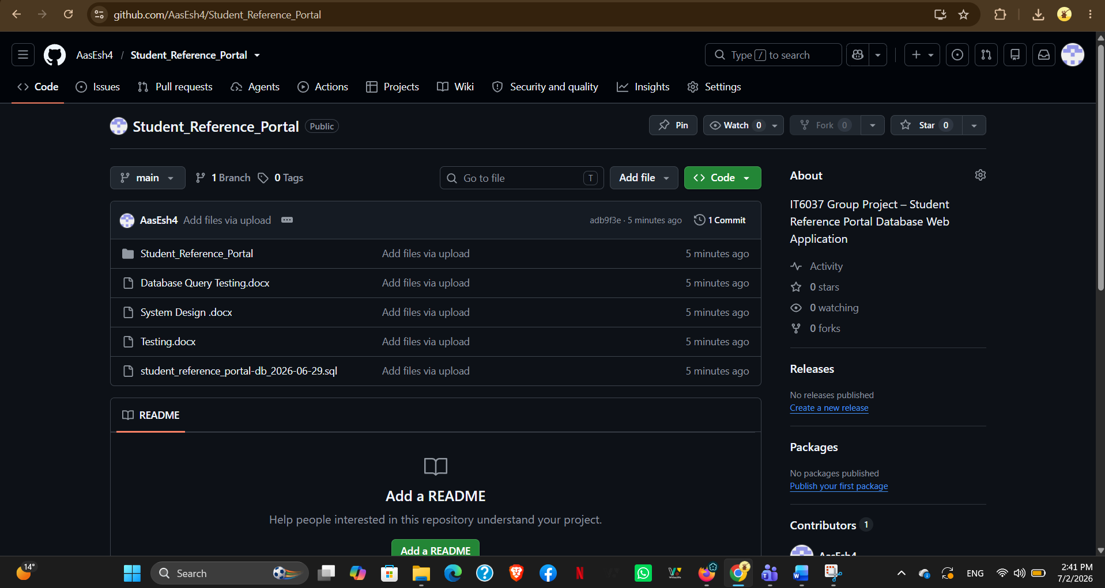

Task Planning
Trello is a tool for task planning and progress tracking, based on kanban board system.
The Kanban board has three columns:
• To Do
• Doing
• Done
This enables the workforce to see the progress of the project and use the appropriate method to manage workload.
5. Project Scope
The development, testing, design and analysis of a website-based application for the management of educational resources using a database is part of this project.
The system will be used to deliver content on three key subject areas:
• Art
• Mathematics
• Technology In each category, there's educational articles about:
• Important concepts
• Historical events
• Biographies of important people
• Major objects The system will be available via a single-page web application and will have to be user role-based.
The project has the following major components:
• Requirement analysis
• Database design
• Database development
• Query development
• Frontend development
• Backend integration
• Testing
• Final documentation Final solution should be safe, easy to operate, efficient and be capable of working all the necessary functions.
6. Requirements Analysis
The project consists of the critical phase of requirements analysis to defining the set of system behaviors and capabilities to meet the client requirements. The requirements for the client were analyzed to understand the required functionalities and constraints of the intended system.
Functional Requirements
Functional requirements outline the operations that the system will support.
The following functional requirements are key:
1. - Students shall be able to search articles using Keywords.
- There shall be an option to add new article for the tutors.
- All Tutors should be able to edit an article.
It is recommended that administrators be able to add articles.
Administrators should have the ability to edit articles.
Admin should have the ability to delete articles. These functional requirements outline the essential functions of the system.
Non-Functional Requirements
Non-functional requirements are a set of requirements that specify the behavior of the system.
The main non-functional requirements are:
Security: Automated and secure authentication and role-based access control shall be provided.
Performance: The database should enable the rapid execution of queries and efficient retrieval of the data.
Reliability : This system should help in maintaining data consistency and minimise downtime.
Usability: The user interface must be simple, user-friendly and intuitive.
Scalability: It should be flexible enough to accommodate future enhancements and other features.
These specifications will help to ensure that the system runs efficiently and delivers a pleasant user experience.

7. Iteration Planning
To structure the project, making it manageable and completed within deadlines, the project has been divided into 5 major stages. These are determined by some deliverables and are components for the successful completion of the project. The team members work from phase to phase by completing certain tasks within phases by taking each phase to be SDLC (Software Development Life Cycle) and then moves on to the next stage. Requirements analysis, team set up, and planning are handled in this phase.
Stage 1
This is concerned with getting the project up and running and its initial setup and requirements, it is vital for this project as it set the standards of development for this particular software application. The team firstly organized their team and assigned a role to each team member, and then created a contract which would serve as team expectations, a guide to teamwork and conflict resolution. It also contained requirements gathering and discussing solutions in the database application.
They also conducted initial planning by defining the tasks for development and the project plan for the duration of this project.
During this phase a ER Diagram was developed that shows the logical structure of the database and the relationship between entities.
Activities Completed:
• Team formation
• Team contract creation
• Requirement analysis
• Trello Setup
• Project planning
• ERD design
Lead Developer: Aashish Sagar Basyal
Due Date:15 June 2026
Status: Completed

Database Design and Development
Stage 2
This is a phase where database structure (tables) is implemented based on the ERD that have been agreed and approved. During this phase, data type for each table column should be carefully chosen, the relationship between tables should be developed and validated. Finally the data which has been given by client for example (samples) will be inserted into the database to make sure the system functions, store data correctly and establish relationship as expected.
Activities:
• Database schema creation
• Table creation
• Relationship implementation
• Import sample data
• Database testing
Lead Developer: Sabin Pandey
Due Date: 22 June 2026
Status: Done

Stage 3.
In stage 3 the databases queries were to be designed and written to run the functionality of the application, In this stage query’s where to be created for reading articles and search queries and in this stage we were to read the articles and display by category and create, read, update, delete and test the data on the database.
Activities:
View by category queries
Search using key word queries
• CRUD queries
• Unit testing
• Query optimisation
Lead Developer: Udit Neupane
Due Date: 27 June 2026
Status: Done

Stage 4
Will develop the web application will be the main task and is the highlight of Stage 4 which includes: UI of the web application will be developed. Web application integration to the database authentication. Role-based access control will be properly implemented The web application has a nice user interface with clear usage of fields and components such that users will have no difficulties interacting with the database
Activities:
• Frontend design
• Backend development
• Database integration
• Authentication system
• Role-based access control
• CRUD interface implementation
Lead Developer: Keyur Bhaveshbhai Patel
Due Date: 30 June 2026
Status: Done
At the conclusion of the process, the students will undergo the final testing, documentation, and submission stage.

Stage 5
Stage 5 is the final stage of the project involving testing of the system, fixing of bugs and preparation of the final documentation and submission. The final testing shall be carried out within the team to find the flaws if any in the application. Critical bugs will be fixed before the submission of the project, within this stage documentation such as test plans, test cases and submission document.
Activities:
• Final testing
• Bug fixing
• Documentation completion
• Final submission preparation
Lead Developer: Emon Aryal
Due Date: 03 July 2026
Status: Completed

8. Task Allocation
Task allocation is important for ensuring balanced workload distribution among team members. Each member has been assigned responsibilities based on project needs and team planning.
Task | Assigned Members | Status
Team Contract | Aashish Sagar Basyal | Completed
ERD Diagram | Emon Aryal, Aashish | Completed
Planning Document | Aashish, Emon | Completed
Database Development | Sabin Pandey | Completed
Query Development | Udit Neupane | Completed
Web Application Development | Keyur Patel | Completed
Testing | All Members | Completed
Task allocation helps improve accountability and ensures that each member contributes to project success.

9. Current Progress
The team has made initial progress in project planning and database design.
Completed tasks include:

• Team Contract
• Requirements Analysis
• Planning Document
• ERD Diagram
• System Design
• Database Development
• Database Queries
• Testing Document
• GitHub Repository
• Student Reference Portal

Currently in Progress
• Reflective Journal
• Peer Evaluation
• Final Documentation

Pending
• Final Submission
The project has completed its planning, design, implementation, and testing phase. Currently, only final reports, reflective journals, peer assessment and the final project is left to submit. At the moment, the project is on its new revised time schedule and has been ready to be handed over for the final project delivery.
10. Risk Management
Risk Management as Part of Planning Risk management is a crucial aspect of any planning process, particularly that of a project. It aims to identify all foreseeable obstacles that could have a negative influence on the project timeline or delivery of work. By being able to detect issues ahead of time, the team has time to formulate strategies to counter them.
Issues at Different Levels The project may come across a number of obstacles along the way, whether that’s through difficulties with communications, scheduling or technical challenges, to issues with teamwork and communication between the group members.
Risk management procedures would allow all of these issues not to interfere unduly with project finalisation.
The major risks identified for this project are listed below.
Risk | Impact | Solution
Delayed task completion | High | Better planning and stricter deadlines
Communication issues | Medium | Regular meetings and progress updates
Technical difficulties | High | Team collaboration and tutor support
GitHub merge conflicts | Medium | Frequent commits and branch management
Workload imbalance | Medium | Fair task distribution and monitoring
Delayed Task Completion
One major risk is delays in completing assigned tasks. Since the project has multiple stages and deadlines, delays in one stage can affect the entire development schedule.
To minimise this risk, the team will:
- Set clear deadlines
- Monitor progress regularly
- Reallocate tasks when necessary
Communication Issues
Poor communication can lead to misunderstandings, delays, and inefficient teamwork.
To reduce this risk, the team will:
- Maintain regular communication
- Hold meetings frequently
- Share progress updates consistently
Technical Difficulties
The project involves database development, backend integration, and web application implementation. Technical challenges may arise during development.
To manage this risk, the team will:
- Work collaboratively on technical issues
- Research solutions
- Seek tutor guidance when necessary
GitHub Merge Conflicts
Since multiple team members may work on code simultaneously, merge conflicts may occur.
To reduce this risk, the team will:
- Commit code regularly
- Use proper branching strategies
- Review code before merging

11. Kanban Board
The Kanban Project Management method was used to organize, keep track of, and control the progression of all Software Development Life Cycle (SDLC) tasks. A visual representation of workflow management and progress for the entire project was offered by the Kanban board. With the assistance of this, everyone on the team was aware of the project's status, what was coming up, what was in progress, and what had been finished.
Kanban boards make it possible for team members to interact more effectively since everyone knows who is doing what and the general pace of development.
A digital board on Trello was made, offering a convenient way for team members to quickly observe what was happening in the project. On the board, each task involved in development was given its own task card, which included the responsible team member, a description of the task, priority, due date, and completion status. Team members had the ability to transfer cards from one column of workflow to another, allowing the project's stage of completion to be clearly displayed. For this project, which adopted the Agile method of software development, the Kanban board had a crucial role.
Each project task was developed and distributed amongst the relevant team members at the beginning of each cycle.
The team gathered regularly to discuss, review, and update the board in order to track finished projects, spot problems, and redistribute tasks if needed. This increased everyone's sense of responsibility, workload sharing, and communication within the Nepali Tech team.
Throughout the project, the Kanban board provided several benefits, including:
- Improved project planning and task organisation.
- Better communication among team members.
- Clear visibility of project progress at every stage.
- Early identification of delayed or blocked tasks.
- Balanced workload distribution among team members.
- Improved collaboration through regular progress updates.
- Better tracking of completed project milestones.
To provide a structured workflow, the Kanban board was divided into five primary sections.
Backlog
Backlog contained all items of the requirements of a project and the additional work of development which has been discovered in planning but have not yet made up schedule yet. All items in backlog will be studied and prioritized before proceeding to Development.
To Do
Tasks were assigned for the current sprint but had not yet started, in the "To Do" column. Work here is ready for a team member as soon as they have the capacity to take something on.
In Progress
Tasks in this column are ones in progress by one or more team members. Those tasks are regularly followed in the team meetings to make sure their progress remains stable and that technical or communication blockers can be dealt with by any team member.
Review / Testing
Post-development, tasks were transitioned into the Review/Testing column where they were checked against the business requirements and tested on aspects of functionality, correctness, usability, and any discovered bugs/errors were rectified prior to the task being considered done.
Done
In The Done column all tasks have been completed, reviewed, tested and accepted by the team. Tasks placed in this column gave the team visibility into project status and how much work was left.
Initial Kanban Board
At the initial stages of the project, most of the tasks on the Kanban board were related to planning and analysis. Emphasis was placed on the Team contract, Project planning, Requirement analysis and ERD design to prepare a strong basis for the database development to start.
Figure 11.1. Initial Kanban Board showing task allocation during project planning.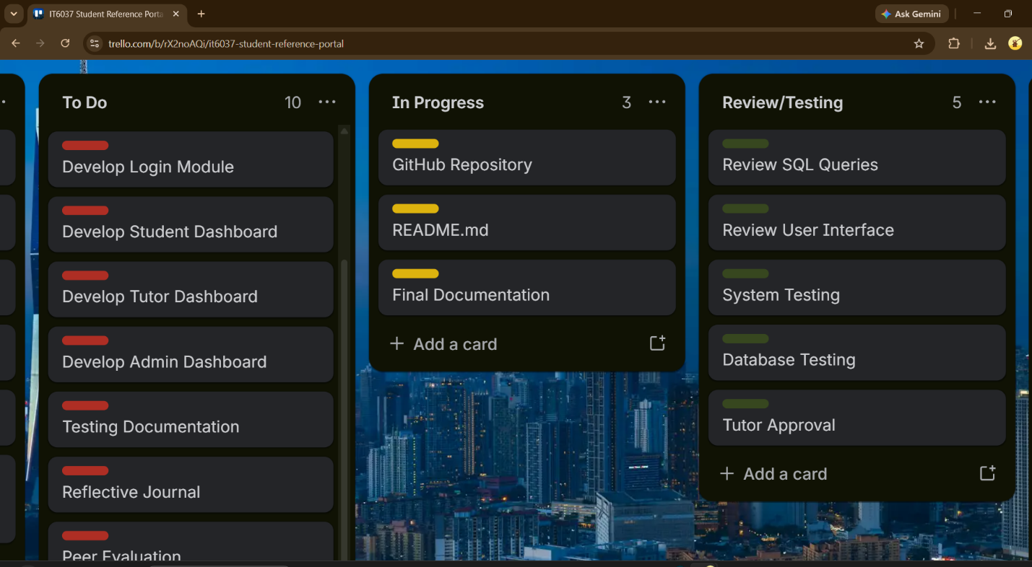shows the initial Kanban board used during the planning phase, including project setup, task allocation, and early development activities.
Mid-Development Kanban Board
After some development time passed, a number of planning tasks were created and added to the done column. Now database development, implementation of SQL query, and web application development took up the center of attention of the team. In this phase the board was regularly updated after meetings to ensure development was going as planned.
Figure 11.2. Mid-development Kanban Board showing database and implementation progress.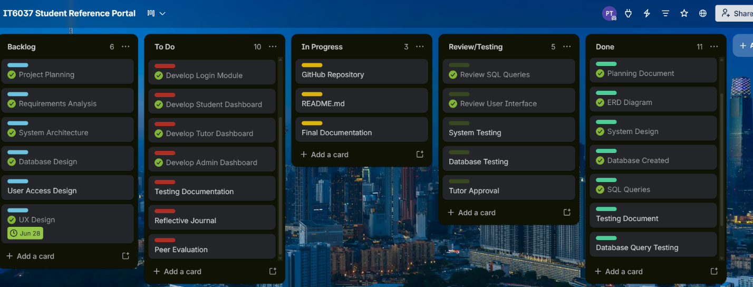
Figure 11.2 illustrates the progress made during the middle stages of the project, where database implementation and query development were actively being completed.
Final Kanban Board
As the project draws to a close the bulk of the development activities have been done, tested and completed within the ‘Done’ category. The last remaining items on the task list are writing the final project report and compiling and submitting the final report. The last remaining tasks were; completing a personal reflection, completing a peer assessment of my work, writing a reflection journal, completing my reflection diary and the organising the final submission of the project.
Figure 11.3. Final Kanban Board showing completed project tasks before submission.
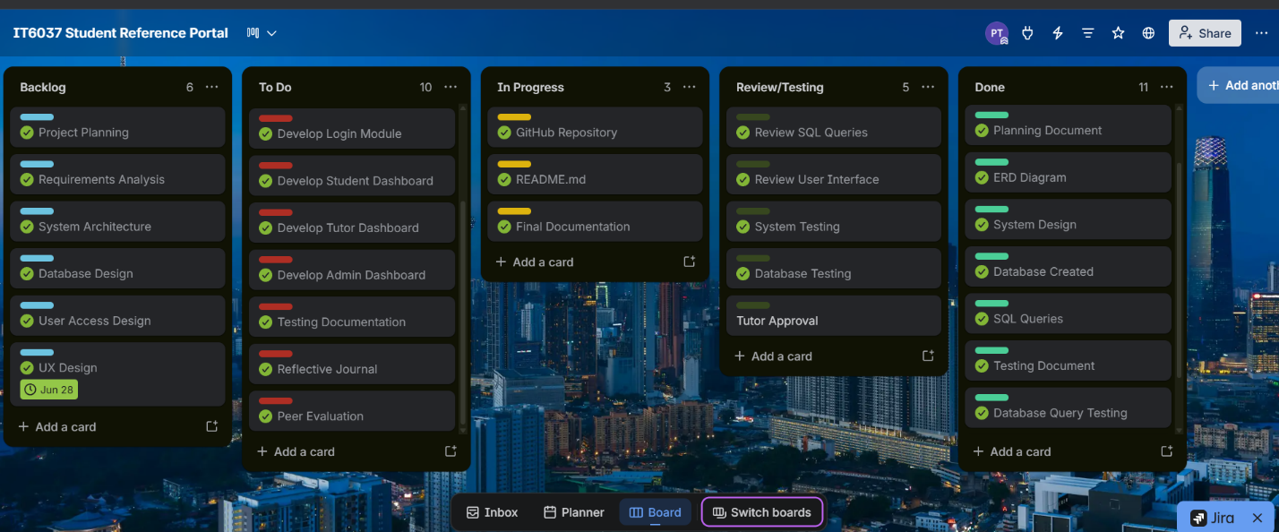

Summary of Final Project Status
At the completion of the project, the Kanban board reflected the following overall status:
Completed (Done)
- Team Contract
- Requirements Analysis
- Planning Document
- ERD Diagram
- System Design
- Database Development
- Database Query Development
- Student Reference Portal Web Application
- Testing Documentation
- GitHub Repository Setup
- README Documentation
In Progress
- Final Documentation Review
- Reflective Journal Preparation
Pending
- Peer Evaluation Forms
- Final Project Submission

At the conclusion of each iteration the Kanban board was amended, the tool also acted as the project board, to record how work is being carried out, where the project has got up to and to ensure that objectives and goals have been reached within their allocated timescales. Working with the Kanban tool helped boost productivity, co-operation, communication and responsibility.
12. Client Feedback
Clients feedbackClient’s feedback play’s vital role in agile process. The regular client’s feedback leads to maintain the client requirements and client expectations satisfied throughout the project life cycle. In this project, the tutor is acting as client and client approval would be required at end of major project stage. The client and team would show the project deliverable to the tutor after completion of each project stage and accordingly client’s feedback would help to adjust the system for the betterment.
Client feedback records will be maintained below.
Stage 1 – Requirements Analysis and Planning
Tutor Feedback:
- Good start to the project.
- Expand the planning document.
- Ensure all team members have assigned tasks.
Action Taken:
- Planning document was improved.
- Team roles and responsibilities were clearly assigned.
Status: Completed

Stage 2 – Database Design
Tutor Feedback:
- Database design is appropriate.
- Check table relationships and data types.
Action Taken:
- Reviewed the ERD.
- Corrected database relationships where required.
Status: Completed

Stage 3 – Database Queries
Tutor Feedback:
- Queries are working correctly.
- Test all CRUD operations before implementation.
Action Taken:
- Additional testing was completed.
- Minor SQL issues were corrected.
Status: Completed

Stage 4 – Web Application
Tutor Feedback:
- Application works well.
- Improve the user interface and navigation.
Action Taken:
- User interface was improved.
- Navigation and layout were updated.
Status: Completed

Stage 5 – Final Submission
Tutor Feedback:
- Ensure all required documents are included.
- Check formatting and submission requirements before submitting.
Action Taken:
- Documentation was reviewed.
- Final project files were organised for submission.
Status: Ready for Submission

13. Conclusion
In conclusion, the planning of the Student Reference Portal established a strong foundation for a project success and revealed the impact of effective project management in software development projects.
This Planning Document is intended to serve as an extensive plan that aims for the success in the Student Reference Portal development, a part of IT6037 Project. It comprises the project objectives, scope, methodology, collaboration approach, iteration plan, task distribution, risk management, and a timeline for the project execution. The planning of the above aspect has guided the team in establishing a clear path toward their overall goals.
The team followed the Agile methodology in their approach to ensure continual planning, constant communication and iterative progress. They also made an efficient use of technology in order to facilitate collaboration and effective progress tracking using GitHub as their version control system, Microsoft Teams for communication and document sharing, and Trello for task assignment and progress management. Constant communication within the team, including daily meetings, helped the team to promptly resolve problems and work through each stage of project work. The Kanban board also provided them a platform to keep a tab on every task.
With this planning, the project also involved several critical components of software delivery: requirements management, database design, software architecture, development, testing, and document production. They used to discuss with the tutor from time to time so that we can enhance and modify our work accordingly. The feedback they received helped them to modify the project at each stage and bring it to the level that met the criteria and the expectations of the client.
To sum up, the planning of the project, communication, and teamwork were essential in the delivery of this database web application. In order to guarantee the successful delivery of the project and achieve the objectives, they maintained strict compliance with the planning document and regularly monitored progress.

